**Shopping Center Kiosk System using Cloud Services and Machine Learning**

Abhirup Mukherjee Gaurav Bose Anirudh Dahiya

School of Computer Engineering, VIT University, Vellore, India

*Under the guidance of:*

Professor Rajeshkannan R

School of Computer Engineering, VIT University, Vellore, India

**Abstract -** *Smart systems use the new, previously unavailable data, which is collected through Internet of Things architecture and objects, to become smart and identify the needs of the system and the consumers without any external help. Path breaking advancements in the field of Machine Learning and Artificial Intelligence are the backbone of these technological endeavors. A key challenge for these rapidly growing smart systems of today is to understand how to leverage these newfound insights to fundamentally change the way certain environments within the society operate. Toward this goal, the Internet of Things (IoT) has great potential to overcome the existing disadvantages in current shopping centre systems given its ability to embed smart technology into real-life urban contexts and allowing for collection of previously intangible data. The developments in the field of Machine Learning also mean that we already have access to a technology is not only smart enough to absorb newfound information, and respond, in speech or action, without relying on hard coded command statements, but also is getting smarter and more insightful with every passing week. In this paper, we show how this paradigm can be applied to a shopping centre domain and present a Kiosk System, an IoT enabled, bot system designed for vendors and consumers. It provides several novel services and functionalities: 1)* ***data collection capabilities*** *and 2)* ***information leveraging capabilities****. Data collection capabilities refer to the system’s to use its various sensors to collect information about the user that can then be leveraged to gain useful insights. These insights refer to the system’s information leveraging capabilities, and could help vendors and consumers in developing a better understanding of each other’s behavior allowing for better inventory control, targeted discounts, organized logistics and cheaper, more economical goods. We present the technical system behind this system and report on results from a self-made proof of concept that allows for a study of the feasibility of such a system*.

**Keywords** – Mall Kiosk System, Cognitive Services, IoT, Cloud Services

# Introduction

The Kiosk System is meant to be a standalone universal windows application maintained by shopping centers. The system will provide functionalities like the ability to interact naturally with users, take pictures, register the user on the system and display useful information to the user, all done hands-free through simple voice commands in a kiosk located inside the mall. The system will be designed to allow vendors to track information like demographics and conditions under which successful purchases are made and this information can then be used to create a prediction model. The Kiosk System is unique in the way that it combines the abilities and functionalities of **IoT, NLP, Machine Learning and bots** where the data processing takes place in a **Cloud** **based system**. Multiple systems currently under development focus on only one of these innovations, failing to recognize the benefits of combining all the systems. Together the systems are capable of functioning as a powerful shopping assistant that is powered by the shopper’s voice, thus also adding a layer of security to the system. The system could do this by identifying and registering the user’s voice in its cloud database.

# Literature Survey

**2.1 Internet of Things (IoT)**

The Internet of Things is a technological revolution that represents the future of computing and communications, and its development depends on dynamic technical innovation in a number of important fields, from wireless sensors to nanotechnology [1]. It’s a system of related and interconnected computing devices, mechanical and digital machines, and human beings that are provided with a unique identification code and the ability to transfer germane data over a network without requiring any form of external input or human-to-human or human-to-computer interaction. This form of constant connectedness and ease of sending information over the network by each individual node or ‘thing’ is what makes the concept of the Internet of Things truly revolutionary. This is because in principle, the presence of this new information allows us to fill in a vacuum that existed previously because of our inability to access or quantify such information. A simple example here, adds clarity about how the Internet of Things is slowly changing our lives by utilizing and leveraging previously unavailable in data in novel and powerful ways.

Let’s look at one example. In 2007, a bridge collapsed in Minnesota, killing many people, because of steel plates that were inadequate to handle the bridge’s load. When we rebuild bridges, we can use smart cement: cement equipped with sensors to monitor stresses, cracks, and wear and tear. This is cement that alerts us to fix problems before they cause a catastrophe. And these technologies aren’t limited to the bridge’s structure.

If there’s ice on the bridge, the same sensors in the concrete will detect it and communicate the information via the wireless internet to your car. Once your car knows there’s a hazard ahead, it will instruct the driver to slow down, and if the driver doesn’t, then the car will slow down for him. This is just one of the ways that sensor-to-machine and machine-to-machine communication can take place. Sensors on the bridge connect to machines in the car: we turn information into action.

You might start to see the implications here. What can you achieve when a smart car and a smart city grid start talking to each other? We’re going to have traffic flow optimization, because instead of just having stoplights on fixed timers, we’ll have smart stoplights that can respond to changes in traffic flow. Traffic and street conditions will be communicated to drivers, rerouting them around areas that are congested, snowed-in, or tied up in construction.

So now we have sensors monitoring and tracking all sorts of data; we have cloud-based apps translating that data into useful intelligence and transmitting it to machines on the ground, enabling mobile, real-time responses. And thus bridges become smart bridges, and cars smart cars. And soon, we have smart cities, and…. This is basically object-to-object communication. And it isn’t some dreamy sci-fi vision of the future. In fact, it’s a technology concept that has been in use all around us for years; think about the disc-shaped antishoplifting devices and the bar codes that have been clamped onto clothing and most items available in shopping markets and department stores for years. What has changed, with time, is that the devices have become smaller, smarter, more durable, and cheaper. As a result, object-to-object communication has become practical for exponentially more uses, enabling a “silent commerce” that requires no human interaction, the foundation of the concept of Internet of Things. Companies and consumers alike are rushing to adopt the technology to reduce costs, improve security, and engage other potential interacting actors, and this happening, at a time when many constituent technologies are still in their nascent stages of development. Our ability to analyze information that is now becoming available to us in quantities too large to comprehend by ourselves, is growing at an exponential rate, every day machine learning and deep learning algorithms are crunching numbers and providing insights, something a single human would not have been able to do over a year. Even RFID systems are still in their infancy. As these become more sophisticated and widespread, they will begin to reshape companies, supply chains, even entire industries. It’s no exaggeration to say that a tiny tag may one day transform the way we live our daily lives, and that that day may not be very far off.

The concept of the Internet of Things has evolved from the convergence of improved wireless technologies, micro-electromechanical systems (MEMS), microservices and the advent of the golden age of internet. The coming together of these technological factors has assisted in reducing the threshold between operational technology (OT) and information technology (IT), allowing unstructured machine-generated data to be accessed and analyzed for insights that then drive improvements.

The first Internet appliance was a Coke machine at Carnegie Melon University in the early 1980s. Programmers working several floors above the vending machine wrote a server program that kept track of how long it had been since a storage column in the machine had been unfilled. The programmers could connect to the machine over the Internet, check the status of the machine and determine whether or not there would be a cold drink awaiting them, should they decide to make the trip down to the machine [2].

Garter’s Information Technology Hype Cycle [3] is a way to represent emergence, adoption, maturity and impact on applications of specific technologies (2) In the adjacent graph, X- axis denotes expectations and Y- axis denotes time factors (3) Internet of Things has been identified as one of the emerging technologies in Internet of Things as noted in Gartner’s IT Hype Cycle (4) It has been forecasted that Internet of Things will takes around 5-10 years for market adoption as of the 2012. See the picture for data.

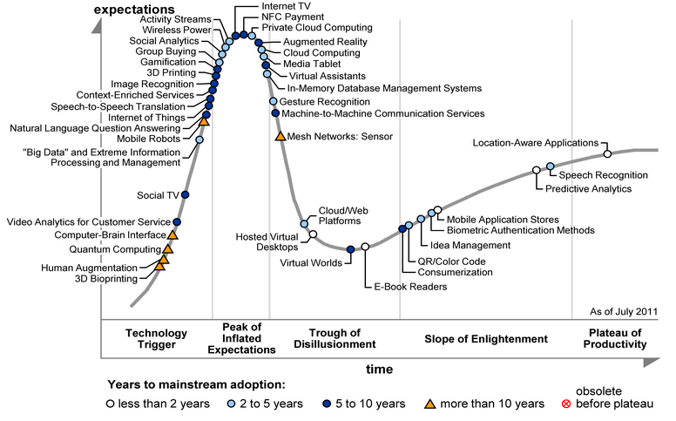

**Timeline** [4]:

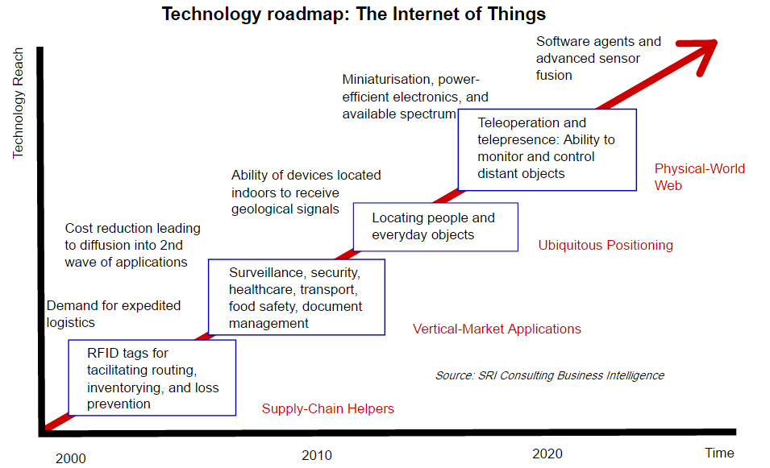

IPv6’s huge increase in address space is an important factor in the development of the Internet of Things. According to Steve Leibson, who identifies himself as “occasional docent at the Computer History Museum,” the address space expansion means that we could “assign an IPV6 address to every atom on the surface of the earth, and still have enough addresses left to do another 100+ earths.” In other words, humans could easily assign an IP address to every "thing" on the planet. An increase in the number of smart nodes, as well as the amount of upstream data the nodes generate, is expected to raise new concerns about data privacy, data sovereignty and security. Practical applications of IoT technology can be found in many industries today, including in precision agriculture, building management, healthcare, energy and transportation.

One of the biggest benefits of the IoT revolution is the pricing of its components. The push for such cheap components originated mostly due to the thriving smartphone industry that has established itself firmly in China. To get a better understanding of the phenomena, let’s take a look at Shenzhen, the home of the largest—and most notorious—Foxconn factory, the place where the much loved IPhone is manufactured. The parts for IPhones, and other such smartphones, have created a world center for IoT building blocks: sensors, cameras, GPS, and most importantly, wireless transceivers.

In Shenzhen, you could start with a basic application processor from Mediatek or one of its competitors. Once you have an ARM processor, you could procure a pared-down embedded Linux software engine, and a network stack—everything you need for internet connectivity, with and without wires. You could then add your choice of sensors and drivers, hire a manufacturing contractor to assemble your IoT system according to your own specification and you’re in business, all for less than $100 to $200. This is much cheaper than installing an expensive laptop or computer system, which lacks the dedicated software to perform the required function, in an environment like a shopping center.

## Microsoft Cognitive Services

Microsoft has developed a set of cloud based APIs that are collectively known as the Microsoft Cognitive Services APIs [27]. These APIs provide the user with a range of different functionalities and are an example of what has come to be known as cognitive computing. Cognitive Computing is a broad base description for technology platforms that are based on the scientific discipline of Artificial Intelligence and Data Processing. These platforms encompass machine learning, reasoning, natural language processing, speech and vision, human-computer interaction, dialog and narrative generation and more [13][14]. In general, the term cognitive computing has been used to refer to new hardware and/or software that mimics the functioning of the human brain [24][25] and helps to improve human decision-making [26]. For our project, we shall be using 3 major Cloud Based APIs:

**Computer Vision API:** This API provides state-of-the-art algorithms to process images and return information [28]. For example, it can be used to determine if an image contains mature content, or it can be used to find all the faces in an image. It also has other features like estimating dominant and accent colors, categorizing the content of images, and describing an image with complete English sentences. You could use optical Character Recognition (OCR) detects text in an image and extract the recognized words into a machine-readable character stream allowing for functionalities such as users taking photos of text instead of copying manually to save time and effort. The API could also be used with videos files by extracting frames of the video from a device and then sending those frames to the API calls of your choice allowing for a fast and reliable analysis of the video’s content. Additionally, it can also intelligently generate images thumbnails for displaying large images effectively.

**Emotion API:** This API takes a facial expression in an image as an input, and returns the confidence across a set of emotions for each face in the image, as well as bounding box for the face, using the Face API [29]. If a user has already called the Face API, they can submit the face rectangle as an optional input. The emotions detected are anger, contempt, disgust, fear, happiness, neutral, sadness, and surprise. These emotions are understood to be cross-culturally and universally communicated with particular facial expressions.

**Face API:** This API provides the user with two main functionalities that are namely Face detection with attributes and face Recognition and is widely used in many scenarios including security, natural user interface, image content analysis and management, mobile apps, and robotics [30]. Four face recognition functions are provided: face verification, finding similar faces, face grouping, and person identification.

The final proof of concept leverages the various functionalities of all the above mentioned Cloud APIs, thus allowing for the creation of a unique system.

## Machine Learning (ML)

Machine learning is the subfield of computer science that gives computers the ability to learn without being explicitly programmed [31]. It’s the science of getting computers to act without being explicitly programmed. In the past decade, machine learning has given us self-driving cars, practical speech recognition, effective web search, and a vastly improved understanding of the human genome. Machine learning is so pervasive today that you probably use it dozens of times a day without knowing it. Many researchers also think it is the best way to make progress towards human-level AI.

Machine Learning is most commonly leveraged as a predictive tool. The first effect of machine intelligence will be to lower the cost of goods and services that rely on prediction. This matters because prediction is an input to a host of activities including transportation, agriculture, healthcare, energy manufacturing, and retail. We are going to focus on how we can use the abilities of Machine Intelligence in the sector of retail. When the cost of any input falls so precipitously, there are two other well-established economic implications. First, we will start using prediction to perform tasks where we previously didn’t. Second, the value of other things that complement prediction will rise.

As machine intelligence lowers the cost of prediction, we will begin to use it as an input for things for which we never previously did. As a historical example, consider semiconductors, an area of technological advance that caused a significant drop in the cost of a different input: arithmetic. With semiconductors we could calculate cheaply, so activities for which arithmetic was a key input, such as data analysis and accounting, became much cheaper. However, we also started using the newly cheap arithmetic to solve problems that were not historically arithmetic problems. An example is photography. We shifted from a film-oriented, chemistry-based approach to a digital-oriented, arithmetic-based approach. Other new applications for cheap arithmetic include communications, music, and drug discovery.

The same goes for machine intelligence and prediction. As the cost of prediction falls, not only will activities that were historically prediction-oriented become cheaper — like inventory management and demand forecasting — but we will also use prediction to tackle other problems for which prediction was not historically an input.

Consider navigation. Until recently, autonomous driving was limited to highly controlled environments such as warehouses and factories where programmers could anticipate the range of scenarios a vehicle may encounter, and could program if-then-else-type decision algorithms accordingly (e.g., “If an object approaches the vehicle, then slowdown”). It was inconceivable to put an autonomous vehicle on a city street because the number of possible scenarios in such an uncontrolled environment would require programming an almost infinite number of if-then-else statements.

Inconceivable, that is, until recently. Once prediction became cheap, innovators reframed driving as a prediction problem. Rather than programing endless if-then-else statements, they instead simply asked the AI to predict: “What would a human driver do?” They outfitted vehicles with a variety of sensors – cameras, lidar, radar, etc. – and then collected millions of miles of human driving data. By linking the incoming environmental data from sensors on the outside of the car to the driving decisions made by the human inside the car (steering, braking, accelerating), the AI learned to predict how humans would react to each second of incoming data about their environment. Thus, prediction is now a major component of the solution to a problem that was previously not considered a prediction problem.

We are going to do a bit of both in the implementation of our system. Not only are we going to use Machine Learning to solve problems that have historically been dependent on predictive analysis, such as inventory control, we are also going to use the new insights to help consumers make their decisions. Depending on how closely aligned our system’s intelligence is with the user’s final decision, we can fine-tune our algorithm’s accuracy, using a method known as online machine learning, wherein every classification output is used to self-correct and orient the system to become more and more accurate over time. A classic example of where such an algorithm has already been implemented is the cloud APIs we will use to identify the various characteristics of our customer through image and voice input. Microsoft’s Cognitive Services are a set of machine learning algorithms that have been trained using hundreds and thousands and millions of inputs of pre classified images, texts, videos and audio clips, to create a system that is capable of identifying patterns the human mind is simply incapable of seeing. We want to help conceptualize and create a similar algorithm for the customers of our smart shopping center.

## Natural Language Processing (NLP)

Natural language processing is a field of computer science, artificial intelligence, and computational linguistics concerned with the interactions between computers and human (natural) languages. As such, NLP is related to the area of human–computer interaction. Many challenges in NLP involve: natural language understanding, enabling computers to derive meaning from human or natural language input; and others involve natural language generation.

Modern NLP algorithms are based on machine learning, especially statistical machine learning. The paradigm of machine learning is different from that of most prior attempts at language processing. Prior implementations of language-processing tasks typically involved the direct hand coding of large sets of rules. The machine-learning paradigm calls instead for using general learning algorithms — often, although not always, grounded in statistical inference — to automatically learn such rules through the analysis of large corpora of typical real-world examples. A corpus (plural, "corpora") is a set of documents (or sometimes, individual sentences) that have been hand-annotated with the correct values to be learned.

## Chat Bots

A chatterbot (also known as a talkbot, chatbot, Bot, chatterbox, Artificial Conversational Entity) is a computer program which conducts a conversation via auditory or textual methods. Such programs are often designed to convincingly simulate how a human would behave as a conversational partner, thereby passing the Turing test. Chatterbots are typically used in dialog systems for various practical purposes including customer service or information acquisition. Some chatterbots use sophisticated natural language processing systems, but many simpler systems scan for keywords within the input, then pull a reply with the most matching keywords, or the most similar wording pattern, from a database.

# Methodologies

## Proposed System

The aim is to create a Kiosk Bot that combines the fields of Machine Learning, NLP and IoT to provide features such as targeted customer suggestions and analysis of the market and purchasing patterns to create a smart system that optimizes and enhances customers’ shopping experience and helps reduce the price of good without compromising vendors’ ability to make a healthy profit. In laymen term the project can be described as a simplistic kiosk. But an overlook of the technologies used and the future scope gives us the vast possibilities and the extensible nature of the project.

LUIS or language understanding intelligent service is the tool that contains our training material to identify the user’s intent, for example “My name is xyz” or “I want to take a picture” and its other variations will be detected and the user intent will be identified. Following this the sensors are activated using a Raspberry Pi.

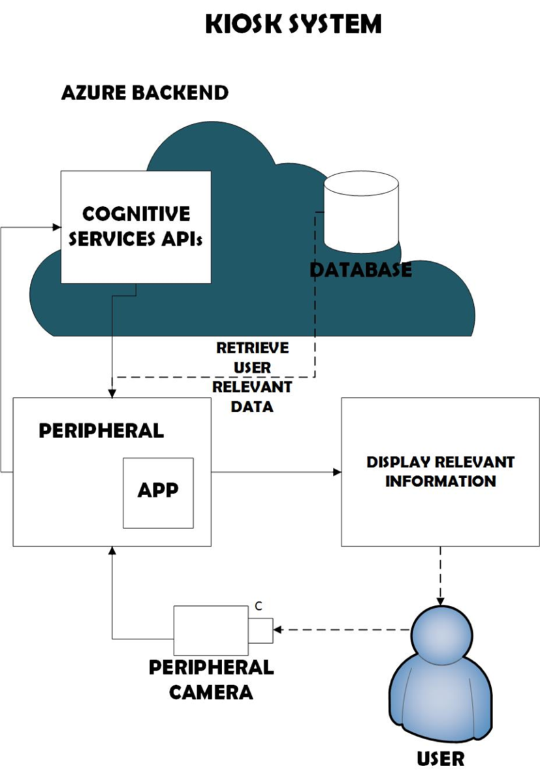

## Engineering Process Model

The process model we will be implementing is Incremental Model. This is a method of software development where the product is designed, implemented and tested incrementally (a little more is added each time) until the product is finished. It involves both development and maintenance. The product is defined as finished when it satisfies all of its requirements. This model combines the elements of the waterfall model with the iterative philosophy of prototyping.

The incremental model allows us to add functionalities to the project via Increments. It allows us to get a working model quickly and then evolve the model by adding increments. After each iteration, testing is conducted. During this testing, faulty elements of the software can be quickly identified. Customer can respond to features and review the product for any needful changes.

**Engineering Process:**

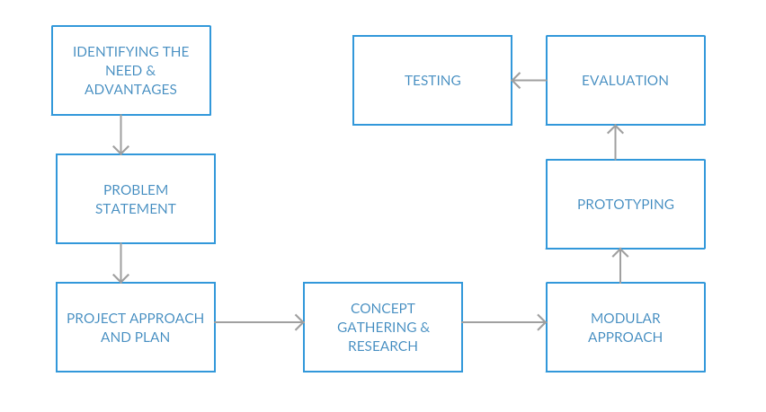

## Functionalities

The proof of concept has 2 high level modules as follows: The first is the data collection module, and the second is the information leveraging module. Together these modules function as a smart kiosk for shoppers and customers in large shopping centers. The data collection module uses three different user classifications to categorize and interact with customer.

* Celebrity Users
* Registered Users
* New Users

The whole application is speech integrated making it a hands free kiosk taking voice inputs as commands. The speech system utilizes LUIS to interact naturally with the user and understand natural language and conversation patterns.

Initially the user is asked if he/she would like to get their picture clicked. If user replies with an affirmation, the system understands and, the picture is captured and passed to the different APIs.

**Celebrity Users:** The Computer Vision API [28] allows us to identify if the user is a well-known personality. The API has been trained to identify pictures of over 200k celebrities. So, the photo of the user is passed to the Computer Vision API which returns a name in case the user is a celebrity. This name is further sent to MediaWiki [33], a Wikipedia API which returns information regarding the celebrity. This information is used to find the celebrity is of which field and accordingly the suggestions of shops are shown to him/her. Furthermore, he/she is given suggestions based on their gender [28], emotion [29], the text on their clothes [28] and the accessories they are wearing [28].

If the user is not celebrity the image captured is sent to the Face API to check whether the user has previously visited the kiosk or not.

**New Users:** The Face API [30] generates a face object from the image that is taken by the kiosk. It then matches the object with the entries in the database containing user information. If there is no match for the user in the Face API database, the user is prompted to register with the system. If user agrees, he/she is then asked for their name and contact information and the registration process is completed.

**Registered Users:** If the user has used the kiosk previously or has registered with the system, the Face API [30] returns the user name along with instructions on how to utilize the system. This is followed by providing them with suggestions based on their gender [28], emotion [29], the text on their clothes [28] and the accessories they are wearing [28].

The second and more complex half of the system is the information leveraging system. The system is basically built as a technology that assists shoppers in making choices and identifying brands and products they might like. This is done by using their profile and identifying the stores and items that a person with a profile similar to the user, was most likely to visit.

The possibilities with such a system are endless, for both the customers and the vendors. For instance – the vendors could use the system and its peripherals to keep track of its most loyal customers and reach out to them on a regular and more targeted basis. The system can also be utilized as a very basic, voice driven query bot which provides users with cards containing snippets of useful information they require, such as directions to a store they asked about, or the different restaurants in a user specified price range. Since the system uses a bot capable of making sense of conversations on the basis of context, customers need not memorize hard coded commands to communicate. Let’s say the user is bored on a Saturday afternoon, and wishes to be entertained, it can just type out or speak out to the chat bot that “I am bored!” or “Entertain me!”. The ability of the bot to process Natural Language permits it to translate the wish of the user to one of its predefined functionality such as highlighting the entertainment stores in the mall, or even opening a gateway portal to the in-house movie theater, allowing the user to book them a movie show, right from where they are standing.

Many of these functionalities require us to build a knowledge base, or a training set that can then be used to train a classification model for the data. The construction of this labeled training set happened using an interview system where we collected all the attributes our system is programmed to work with, and then asking the user’s for their favorite store preferences. This process was simulated as we were concerned with building a proof of concept and proving the feasibility of the system module. The simulation gave us a data set of about a hundred people visiting a shopping complex in Hyderabad, India. We utilized this data to identify and classify the demographics of the store customers into categories such as gender, emotion, age, accessories, time of visit and duration of visit. Using these categories, we looked for a classification that would help us categorize each store and help identify the base demographic visiting and/or showing interest in each store.

Once the classification was complete, the system would identify attributes using the sensors and cognitive services, and on the basis of the results, it would guide customers to places that trends indicated they would most enjoy. The system also contained a loyalty reward system, which kept tabs of the number of times a customer visited a certain shop, which would allow the system to align its interactions more closely to the shopper’s preferences.

The working proof of concept executed as expected, displaying both the ability to leverage the knowledge it was gaining from every interaction, and the requisite flexibility for it to satisfy its users’ needs conversationally.

**4. Hardware and Software Requirements**

Software interfaces provide access to resources (such as memory, CPU, storage, etc.) of the underlying embedded system. This includes Web Browsers, Operating Systems; Web Servers like Apache; Cloud Database such as Microsoft Azure; Developer tools such as Django, Bootstrap, Visual Studio, C#, Xamarin, Windows 10 IoT Core; Bot Framework, Microsoft Cognitive Services, Third Party APIs and LUIS for NLP.

Hardware interfaces exist in many of the components in the various I/O devices etc. The various hardware interfaces required are split into three types. The first type is the set of input devices including sensor for light, a camera capable of taking high quality photos and interfacing with Windows 10 IoT core; and a microphone to take voice input. The second type is the set of output devices such as a display panel and a sound system to enable the bot to converse with users using voice output. The third type is the hardware required to interface the input and the output and act as the central hub for the system, i.e. the Raspberry Pi 2 board and the Ethernet cable and Wi-Fi module required to establish connection with the cloud.

**Hardware Used**

The hardware system we use for simulation purposes only is Raspberry Pi 2. The Raspberry Pi is a credit card sized single board computer developed in the UK by the Raspberry Pi Foundation with the intention of promoting the teaching of basic computer science in schools. The Raspberry Pi is manufactured in two board configurations. The Raspberry Pi has a Broadcom BCM2835 system on a chip (SoC), which includes an ARM1176JZFS 700 MHz processor, Video Core IV GPU, and was originally shipped with 256 megabytes of RAM, later upgraded to 512 MB. It does not include a builtin hard disk or solid state drive, but it uses an SDcard for booting and persistent storage. The Foundation provides Debian and Arch Linux ARM distributions for download. Tools are available for Python as the main programming language. The RPI 2 is the heart of our system and is provided internet connection via an Ethernet cable.

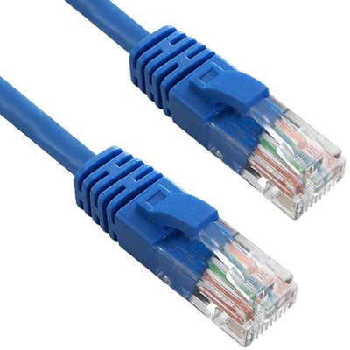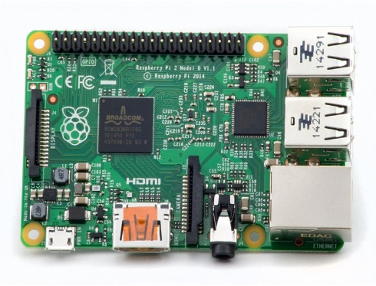

Figure 4.1: RPi 2 Figure 4.2 Ethernet Cables

# System Architecture

## Chosen System Architecture

Client Server model is the chosen system architecture. Interaction happens with the server based on client request. The server is accessed only when a function is performed.

## Component Design

Each component of the Cloud based Kiosk System is carefully designed to work well with each other despite using different types or classes of technologies used to build them. The end point or the point of contact is a bot framework API. It is solely responsible to take in all requests from users. The NLP component decodes the request from the user so as to try and understand which devices are to be used and how to use them so as to satisfy the user. Once it knows what needs to be done, it sends out messages to the system to act.

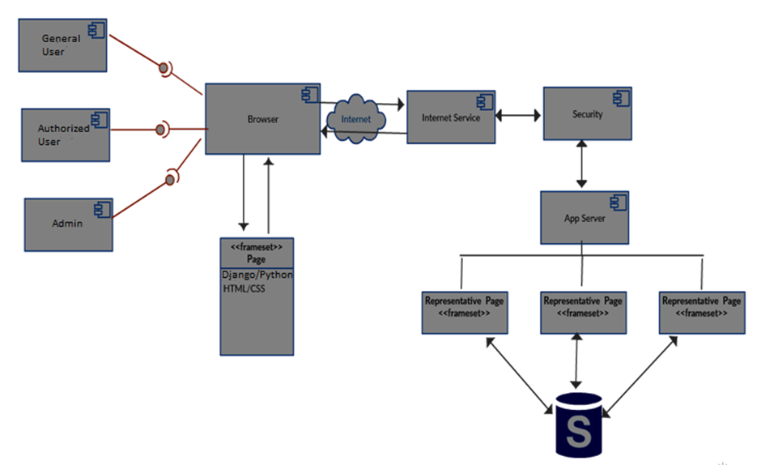

## Data Flow Diagram

The bot ‘talks’ with the user and takes the request as the input. It then passes on this request as it is to the NLP layer of the system that is hosted on the Azure Cloud platform. Here, the request is broken down into commands to be carried out and completed. Next, a picture is taken and converted to a bitstream to be passed to the cloud APIs (Microsoft Cognitive Services). The APIs return attributes extracted from the picture which are sent to and stored in the Azure Mobile Database, also hosted in the Azure Cloud. The Raspberry Pi acts as the central hub facilitator for all of the processes. Once the user attributes are extracted and stored in the database, the system parses them to the classification algorithm we trained using the initial labeled data. The model provides a predictive analysis to identify the stores (and items) the user is most likely to want to browse through and purchase from. We also allow the user to scrutinize the suggestions provided using voice commands, helping them look for store locations, specific items and special discounts and schemes.

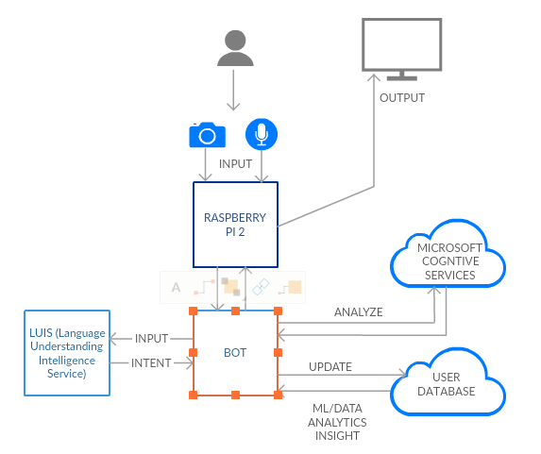

# Security

The more and more we prioritize digital technologies in our day to day environments, the greater the threat to our security becomes. The threat becomes even greater when a product like our scales up to provide services to hundreds and thousands of people across the world. The biggest threat comes from the possibility of sensitive data being stolen from the servers being used to store them. Examples of this are the massive breach of Sony Playstation Network’s database where names, credit card numbers and personal information were stolen from hacked servers. The information our systems collect are just as sensitive as they can be used to track personal preferences and with a large enough dataset, they can be used to identify general trends that could be misused by miscreants.

A secondary threat could come from the hijacking of the IoT components of the kiosk system. Module suppliers who manufacture parts for such systems usually sell millions of identical building blocks to multiple competitors and other Consumer Internet of Things dreamers: DVRs, smart locks, weather stations, lighting systems, home systems and many more. Finished products are usually sold to technically unsophisticated consumers who ignore updates or forget their logins and passwords. The module makers more often than not anticipate this situation and design backdoors: a login/password combination that allows tech support to remotely take control and run updates for users.

This is a well-meaning but terribly lazy arrangement that is extremely simple for hackers to break through. Once they get wind of such systems, using standard Linux dissection tools, they are able to browse the embedded software module and find the backdoor to exploit. This breach can then be used to access all the Internet of Things products from several different makers and manufacturers. Hackers are able to upload software to unsuspecting devices and turn them into weapons for massive denial-of-service (DoS) attacks. Security cameras, sensors, home automation systems, Kiosk system, can all be conscripted into a guerrilla army that incapacitates a website with an overwhelming volume of requests.

The victim of such attacks, aren’t people’s homes, but are political websites that offend the hacker’s sensibilities, or, with increasing frequency, a site that the pirates want to hold for ransom. Even grander and more terrifying attacks have been directed at internet infrastructure services such as DNS (Domain Name System) servers. DNS translates a name such as example.com into its actual, numerical IP (Internet Protocol) address—(example.com = 93.184.216.34). Recently a DoS attack on Dyn caused the massive East Coast internet outage that knocked out Twitter, Netflix, and even the New York Times. No one knows who did it or why, but the implications are dire. Energy and transportation infrastructures or Communication systems could be the next target.

The easy and untraceable penetration and hijacking of cheap Internet of Things devices represent a threat that society has yet to fully understand. This is a simple side effect of the smartphone revolution wherein billions of smartphones created an ecosystem of components, manufacturers, and distributors in a fierce race to the bottom. Corners were cut and we now have an untold number of vulnerable devices lying in wait on the internet. Nobody could have predicted that IoT devices could become such easy target for hackers.

If this sounds exaggerated, take the example of the hole in tech products that recently revealed to the public eye: a hole in a connected objects protocol called ZigBee that’s used, as just one example, by Philips Hue smart bulbs. In a recent New York Times article, John Markoff describes the work of researchers who found an easy way to penetrate the ZigBee network and subvert lighting systems, and any other connected object that uses the protocol.

The Consumer Internet of Things revolution will happen. But it won’t succeed on the back of the cheap and compromised systems most manufacturers are currently selling to customers. For the revolution to happen, manufacturers will need to be held liable for the security of their systems and the privacy of their customers.

# Results and Future Scope

Future scope for the kiosk systems involves streamlining them with the collected data and making them even more efficient and insightful. The amount of data and the scope of the system can be increased to allow it to optimize the entire shopping experience. From being just a kiosk system inside a shopping center, the system could be expanded with the help of IoT sensors that collect metadata from across the area of interest. Once a user is registered, they could benefit from having their behavior being tracked anonymously by our system.

The several ways in which we could go about the collection of all this data, could be by installing RFID sensing technology that recognizes the customers by the way of a unique customer number that is assigned to each and every customer when they register themselves on the kiosk system. Once registered, they could be given shopper tags that could help the array of sensors detect their presence in the several different stores spread across the shopping center. An alternative to this could be a video tracking technology that could track everyone by their face. This solution however poses a huge security and privacy threat to customers and could be interpreted as unlawful surveillance, making it an unfeasible option.

Each customer could then be assigned points for their interactions within the shopping center. A point based system could be created wherein window shopping could be interpreted as mild interest by the system and given a low point, whereas physically entering a store and making a purchase could be assigned a higher point within the data collection system. This kind of input could revolutionize how we are able to optimize and improve every customer’s user experience. For vendors too, this would now lead to an ability to collect hard data on customer behavior. No longer would they have to rely on controlled studies, or emulate the shopping center behavior, hoping to hit upon a trend that exists within the environement. They could now access this information and gain new insights, allowing them to ustilise an uncountable number of strategies to target customers and optimize their retail experience. Some of the ways this data could be utilized in the future are:

**Predicting Lifetime Value (LTV)**

* Can be used to predict the characteristics of high LTV customers, this supports customer segmentation, identifies upsell opportunities and supports other marketing initiatives
* usage: can be both an online algorithm and a static report showing the characteristics of high LTV customers

**Wallet share estimation**

* Working out the proportion of a customer's spend in a category accrues to a company allows that company to identify upsell and cross-sell opportunities
* usage: can be both an online algorithm and a static report showing the characteristics of low wallet share customers

**Churn**

* Working out the characteristics of churners allows a company to product adjustments and an online algorithm allows them to reach out to churners
* usage: can be both an online algorithm and a statistic report showing the characteristics of likely churners

**Customer segmentation**

* If vendors can understand qualitatively different customer groups, then they can give them different treatments (perhaps even by different groups in the company). Answers questions like: what makes people buy, stop buying etc.
* usage: static report

**Product mix**

* What mix of products offers the lowest churn? ex. Giving a combined policy discount for home + auto = low churn
* usage: online algorithm and static report

**Cross selling/Recommendation algorithms**

* Answers questions such as: “given a customer's past browsing history, purchase history and other characteristics, what are they likely to want to purchase in the future?”
* usage: online algorithm

**Up selling**

* Answer’s questions such as: “given a customer's characteristics, what is the likelihood that they'll upgrade in the future?”
* usage: online algorithm and static report

**Channel optimization**

* Identifies the optimal way to reach a customer with certain characteristics
* usage: online algorithm and static report

**Discount targeting**

* Answers the query: “what is the probability of inducing the desired behavior with a discount?” and “who is most likely to change their mind from not buying a product to wanting to buy this product with due to a discount?”
* usage: online algorithm and static report

**Reactivation likelihood**

* Helps identify the reactivation likelihood for a given customer
* usage: online algorithm and static report

**Adwords optimization and ad buying**

* Calculates the right price for different keywords/ad slots within the shopping center area, and in outside communities, helping identify which communities are most likely to respond to the advertisement

**Target market**

* Understanding the target helps you determine exactly what your products or services will be, and what kind of customer service tactics work best
* usage: static report

**Demand forecasting**

* Helps vendors answer questions like: “how many of what thing do you need and where will we need them?” (Enables lean inventory and prevents out of stock situations.)
* Revenue impact: supports growth and militates against revenue leakage
* usage: online algorithm and static report

**Pricing**

* Helps optimize per time period, per item, per store
* Was dominated by Retek which is now known as Oracle Retail

**Location of new stores**

* Helps identify the optimal location for stores, allows for segmentation of stores based on their type to maximize customer flow
* Pioneered by Tesco
* Site Selection in the Restaurant Industry is Widely Performed via Pitney Bowes [AnySite](http://www.pb.com/software/articles/optimize-site-selection-process.shtml)

**Product layout in stores**

* This is called "plan-o-gramming"

**Merchandizing**

* Helps identify when to start stocking & discontinuing product lines

**Inventory Management (how many units)**

* Primarily about specifying the shape and placement of stocked goods. It is required at different locations within a facility or within many locations of a supply network to precede the regular and planned course of production and stock of materials
* In particular, perishable goods

**Shrinkage analytics**

* Theft analytics/prevention [35]

**Warranty Analytics**

* Rates of failure for different components
* And what are the drivers or parts?
* What types of customers buying what types of products are likely to actually redeem a warranty?

**Market Basket Analysis**

* It’s a technique based upon the theory that if you buy a certain group of items, you are more (or less) likely to buy another group of items.
* For example, if you are in an English pub and you buy a pint of beer and don't buy a bar meal, you are more likely to buy crisps

**Cannibalization Analysis**

* Refers to a reduction in sales volume, sales revenue, or market share of one product as a result of the introduction of a new product by the same producer.

**Next Best Offer Analysis** [34]

* NBO allows companies to attract the best customers, offer them the optimal products or services they want, and personalize offers recommendations

**In store traffic patterns**

* Allows vendors to study store traffic patterns and gain insights into how to optimize the same

There’s a school of thought that many U.S. companies are chasing their tails in the quest for the Holy Grail of consumer economics: maximizing the value of customer data, in order to get customers to spend more money. Mainly, companies are depending on old, proprietary marketing and data tools and they’re running in circles, and getting nowhere fast. Sure, marketing departments have made some progress tapping into customer buying habits, historically by relying on customer relationship management software, which aids companies manage customer data and customer interaction, access business information, automate sales, marketing and customer support and also manage employee, vendor and partner relationship. But that isn’t enough.

That’s where predictive analysis enters the picture – a technology tool that information technology directors are increasingly utilizing to upgrade customer retention rates, and to maximize customer return on investment.

Data Analysis has its origins in Amazon.com’s early use of so-called recommendation software, or collaborative filtering, in engineering-speak, to spur shoppers toward a “next best offer” based on site page visits and, of course, actual purchases. SalesForce.com has also just rolled out a software package that assembles prospect data points and automatically translates them into actionable insights, enabling marketing and sales teams to sell smarter. How effective is this insight? The software company SAS says that deployment of data analysis technology and processes “is essential for gaining sustainable competitive advantage and achieving response rates as much as 10 times greater than standard outbound promotions.” Using data analytics, companies garner highly granular customer differentiation, and this provides the basis for delivering a wide variety of customer propositions according to SAS.

Consider Facebook, which maps consumer habits on a real-time basis, 24-7. Every time a Facebook member posts a comment, photo or event, or responds to a comment, photo or event, Facebook logs that data. In that manner, the social media giant is constantly building a user profile of each user that helps Facebook analysts determine in a millisecond what users want to see, and what they are interested in buying. eBay, and its Hunch-driven recommendation service works in a similar way. The online retailer leverages Hunch’s “taste graph” software-based consumer searches and responses to advertising, to push recommendations toward items based on their individual shopping preferences.

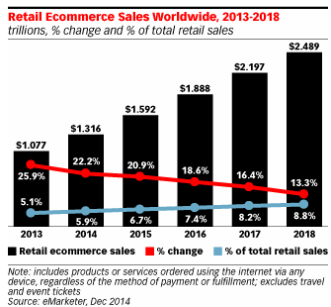

Online retailers like Alibaba, Amazon, Flipkart and many more have been using customer behavior patterns and data to create customized experiences for more than a decade now. This unique user experience has broken the barrier of not being able to experience the product firsthand and contributed to the massive growth seen in the e-commerce sector over the past 10 years. Retail has lost a large share of its customers and revenue to online retailers. The only way to slow this trend towards online shopping is to improve ground level user experience, something that can only happen if shopping ceters and vendors embrace the power of data.

It’s time to redefine on the ground retail businesses using big data. To fully realize big data’s benefits, it is essential to lay a strong foundation for managing data quality with advancing data-processing tools and practices that can scale and be leveraged. Three key features that could contribute to the effectiveness of such a data service would be: first, the data being derived from actual customer shopping actions would make it both more authentic and more useful. Second, if the data is highly structured, with more than 100 attributes in discrete units such as color, price, size, and many other parameters, it would provide better data quality than that offered by a social-network platforms. Finally, the data would have to be comprehensive, with many petabytes (PBs) of data streaming in real time from millions of users per day.

In addition, powerful platforms would be required for processing all the data. Take the example of Alibaba’s cloud batch-data processing platform, MaxCompute, which processed 1.98 million computation jobs on the day of the 2016 Double 11 Festival, using more than 54,000 machines in seven data centers (12 clusters) in three locations. More than 180 PB of data was processed that day. Meanwhile, Alibaba’s real-time data-processing platform, StreamCompute, processed a variety of online transaction types and calculated the GMV in real time. Specifically, the platform processed 95.56 million records per second at the peak (a total of 3.7 trillion records for the day). This challenge is necessary for the system to be as accurate as possible. The more data that we have, the better we will be able to make the shopping experience.

Once we have the data, it would be time to utilize innovative AI to build a “smart” business. Personalized search and recommendation engines help e-commerce platforms better "understand" users’ likes and intentions. In addition, the technology could be leveraged to build comprehensive shopper and seller credit systems and valuation models. The technology would allow vendors to tailor content and products to users based on behavioral characteristics. The study of user behavior data at different shopping stages could be used to derive intelligent algorithms to narrow users’ shopping intentions.

All of this would require the use of various kinds of machine-learning technologies to realize AI, including high-dimensional statistics, online learning, transfer learning, and deep learning. These technologies would enable retailers to scale their business to meet and increase customer demand and produce innovative features in its image, video, and speech-recognition technologies. Overall, these complex technologies will work together to facilitate shopping by providing more choices and greater ease of ordering.

Virtual reality (VR), the creation of a virtual interactive world with computer-generated 3-D imaging, and augmented reality (AR), which superimposes a view or image atop the VR view, to provide a realistic, complete, and tailored picture for a specific user, could also be implemented within shopping centers, allowing users to immerse themselves even further in the experience.

The backbone of such a system would be built by leveraging cloud-computing technologies such as elastic computing, virtualization, and real-time data processing backed by hybrid-cloud architectures. Cloud-computing platforms would also be strategically built to allow small and midsize businesses to operate more efficiently. Cloud computing would provide flexibility based on demand, providing advantages both for vendors’ internal operations and for its many external partners and customers.

The results obtained from constructing such a kiosk system that allows for conversational understanding and leverages and analyzes large quantities of data is that it can drastically improve the individual shopping experience of customers and optimize the inventories and targeting systems of vendors. As for the technological implications and the results, we have succeeded in arranging diverse technologies to enhance and extract the most viable features of each of them, especially – Machine Learning, Cloud Services, and NLP, Azure services over the internet, sensors and devices used in day-to-day life.

Nobody in the market has created a system that leverages data and maximizes benefits for all the parties, in the same way that our product is capable of doing, once scaled up.

# Conclusion

Based on all the systems surveyed and their advantages and drawbacks of these systems, this paper presents the features to be possessed by an ideal system for a fully functional Shopping Center Kiosk System. An ideal system should be capable of providing a unique and valuable service or insight to a user and in real time. Only the Internet and cloud can ensure that access to a system that requires such a lot of processing power, background and historical data and so many different analytical tools can be made available at all times to people in the setting of a market or shopping complex. This will give rise to a revolution amongst traditional retail systems that are currently losing their market share to online e-commerce retailers. The user interface should be easy and fun for customers to use. There should be a lot of thought put into the design of the user interface for these apps. Also, the system should be able to show a tangible benefit to ensure that the users’ information and effort are rewarded with a marked improvement in their shopping experience. The vendors too must be able to enjoy the benefits of the newfound information system so as to justify the sharing of data and their participation in the endeavor. Only then can the kiosk system become commercially viable. Plug-in capabilities will be an added bonus for the system, allowing it to interface with the growing number of applications that people use to make their lives simpler. That is the best way to utilize the benefits of Internet of Things, Machine Learning and Natural Language Processing to change the retail experience around the globe.

# References

[1] <http://www.ieccr.net/comsoc/ijcis/>

[2] Madakam, S. , Ramaswamy, R. and Tripathi, S. (2015) Internet of Things (IoT): A Literature Review. *Journal of Computer and Communications*, **3**, 164-173. doi: [10.4236/jcc.2015.35021](http://dx.doi.org/10.4236/jcc.2015.35021).

[3] Jayavardhana, G., Rajkumar, B., Marusic, S. and Palaniswami, M. (2013) Internet of Things: A Vision, Architectural Elements, and Future Directions. Future Generation.

[4] Apendix F of Disruptive Technologies Global Trends 2025 page 1 Figure 15 (Background: The Internet of Things)

[5] <http://internetofthingsagenda.techtarget.com/definition/Internet-of-Things-IoT>

[6] <https://www.oreilly.com/ideas/ioth-the-internet-of-things-and-humans>

[7] Gonnot, T., Yi, W., Monsef, E. and Saniie, J. (2015) Home Automation Device Protocol (HADP): A Protocol Standard for Unified Device Interactions. *Advances in Internet of Things*, **5**, 27-38. doi: [10.4236/ait.2015.54005](http://dx.doi.org/10.4236/ait.2015.54005).

[8] Ferguson, T. (2002) Have Your Objects Call My Object. Harvard Business Review, June, 1-7.

[9] <http://www.internet-of-things-research.eu/pdf/IoT-From%20Research%20and%20Innovation%20to%20Market%20Deployment_IERC_Cluster_eBook_978-87-93102-95-8_P.pdf>

[10] Kosmatos, E.A., Tselikas, N.D. and Boucouvalas, A.C. (2011) Integrating RFIDs and Smart Ob-jects into a Unified Internet of Things Architecture. Advances in Internet of Things: Scientific Research, 1, 5-12. <http://dx.doi.org/10.4236/ait.2011.11002>

[11] Biddlecombe, E. (2009) UN Predicts “Internet of Things”. Retrieved July 6.

[12] Razzak, F. (2012) Spamming the Internet of Things: A Possibility and its probable Solution. Procedia Computer Science, 10, 658-665. http://dx.doi.org/10.1016/j.procs.2012.06.084

[13] http://www.research.ibm.com/software/IBMResearch/multimedia/Computing_ Cognition_WhitePaper.pdf

[14] http://h20195.www2.hpe.com/V2/GetPDF.aspx/4AA6-4478ENW.pdf

[15] Gershenfeld, N., Krikorian, R. and Cohen, D. (2004) The Internet of Things. Scientific American, 291, 76-81. http://dx.doi.org/10.1038/scientificamerican1004-76

[16] <https://www.cl.cam.ac.uk/archive/ksj21/histdw4.pdf>

[17] <http://citeseerx.ist.psu.edu/viewdoc/download?doi=10.1.1.98.6002&rep=rep1&type=pdf>

[18] <http://www.aclweb.org/anthology/W97-0124>

[19] <http://www.ijteee.org/final-print/nov2013/Natural-Language-Processing.pdf>

[20] <https://lagunita.stanford.edu/c4x/Engineering/CS-224N/asset/slp4.pdf>

[21] <https://www.technologyreview.com/s/602788/googles-new-home-helper-flexes-powerful-ai-muscles/>

[22] <http://postscapes.com/internet-of-things-history>

[23] Chorost, M. (2008) The Networked Pill, MIT Technology Review, March.

[24] Knight, Shawn (2011). IBM unveils cognitive computing chips that mimic human brain TechSpot: August 18, 2011, 12:00 PM

[25] Denning. P.J. (2014). "Surfing Toward the Future". Communications of the ACM. 57 (3): 26–29. doi:10.1145/2566967

[26] <http://www.hpl.hp.com/research/>

[27] <https://www.microsoft.com/cognitive-services>

[28] <https://www.microsoft.com/cognitive-services/en-us/computer-vision-api/documentation>

[29] <https://www.microsoft.com/cognitive-services/en-us/emotion-api/documentation>

[30] https://www.microsoft.com/cognitive-services/en-us/face-api

[31] Phil Simon (March 18, 2013). Too Big to Ignore: The Business Case for Big Data. Wiley. p. 89. ISBN 978-1-118-63817-0.

[32] 1 : Daqing Chen, Sai Laing Sain, Kun Guo. (2012) ‘Data mining for the online retail industry: A case study of RFM model-based customer segmentation using data mining’, Journal of Database Marketing & Customer Strategy Management, Vol. 19, pp. 197-208. doi:10.1057/dbm.2012.17 Research

[33] <https://www.mediawiki.org/wiki/API:Main_page>

[34] <http://www.analyticbridge.com/xn/detail/2004291:Comment:219197>

[35] http://www.internetretailer.com/2004/12/17/retailers-cutting-inventory-shrink-with-spss-predictive-analytic